1-Mail servers of the domain Ibm.com is asia3.akam.net.

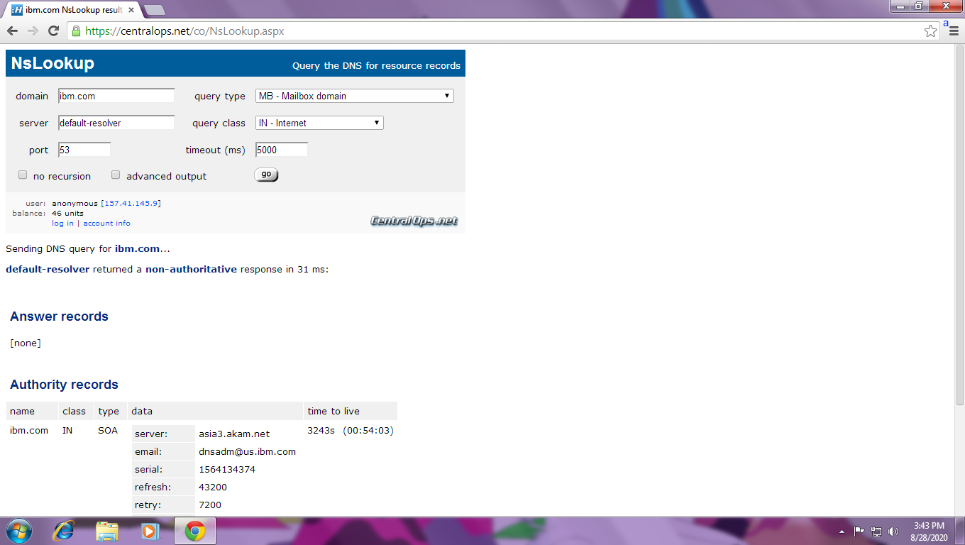

Mail server of wipro.com is ns1.wbindia.com.

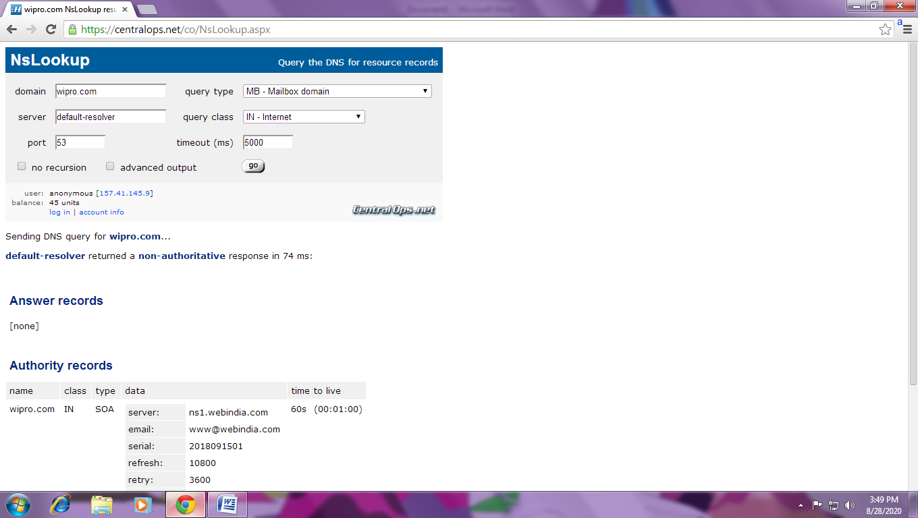

2-The email server of ibm and wipro are both located in USA.

3-No open port found for the ip 203.163.246.23.

4- CVE-2020-10189..

Zoho ManageEngine Desktop Central before 10.0.474 allows remote code execution because of deserialization of untrusted data in get ChartImage in the FileStorage class. This is related to the CewolfServlet and MDMLogUploaderServlet servlets.

